IASSRT Symposium 5, Call for Paper

Textiles on the Silk Roads: from Medieval to Industrial Periods
5th Symposium of the International Association for the Study of Silk Road Textiles (IASSRT)

November 15 – 17, 2021 Online (Microsoft Teams or Zoom)

Centro Studi Martino Martini, University of Trento, Italy
China National Silk Museum, Hangzhou, China

Silk Roads constitute some of the most significant cultural and economic networks that connect many continents and oceans. Textiles flowing through the Silk Roads reflect local diversities and innovations as well as inter-regional influences. These networks are as relevant today as they were in the past. The 5th Symposium of IASSRT, with the theme "Textiles on the Silk Roads: from Medieval to Industrial Periods," was scheduled to take place in Trento, Italy from September 29 to October 4, 2020. However, due to the coronavirus, the symposium was postponed. We had hoped for quite a while that we would be able to hold an in-person symposium this year, but considering the developments of recent months, we had to accept that it will not be possible. Therefore, the symposium for this year will be co-hosted in Hangzhou and Trento on-line.
This symposium invites Italian scholars who will explore the rise of the silk industry in Italy, including the Medici patronage, Italy’s link to the Orient, and the role of cathedrals as repositories of early textiles. The symposium also seeks contributions from international scholars on the use of textiles in diplomatic relationships among regions and various social groups or institutions; the transmissions and influences of textile patterns, techniques, and meanings between East and West; the textile traditions and innovations along the Silk Roads; and the global rise of silk industries as an outcome of Silk Roads interactions.

Symposium format: two days of online lectures and one day of virtual study tours to visit important holdings of Silk Roads textiles via video.

CO-ORGANIZERS
International Association for the Study of Silk Road Textiles (IASSRT)
Centro Studi Martino Martini
University of Trento
China National Silk Museum

CO-CHAIRS: Riccardo Scartezzini, Feng Zhao

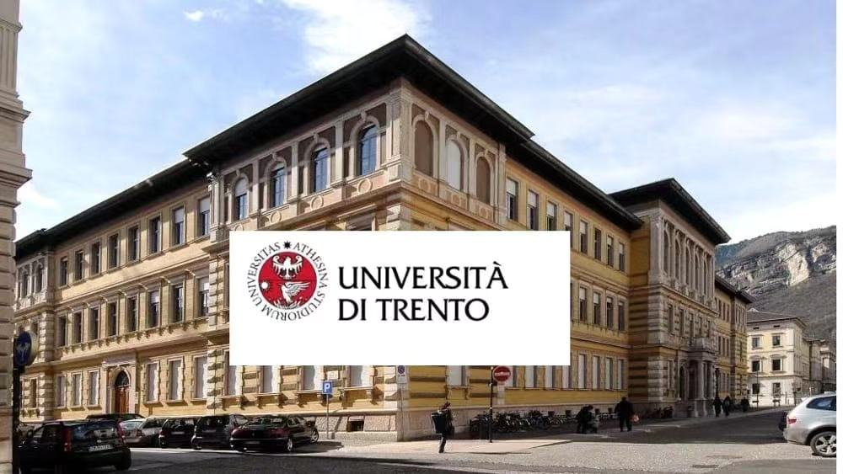
University of Trento

China National Silk Museum

CALL FOR PAPER SUBMISSIONS
Textile/ art/ social historians and textile scholars/ conservators are invited to submit a paper abstract between 250–350 words to: yanghanlin@cnsilkmuseum.org. Registration form is also required (see below). Some possible topics may include, but not limited to:
- The Italian Background to the Rise of the Silk Industry (invited Italian scholars)
- The Soft Diplomacy of Textiles
- Motive, Technique and Meaning. East and West
- Textile Traditions and Innovations
- Rise of Silk Industry
Submission abstract deadline: September 15, 2021. Accepted proposals will be notified by October 5. Submission full paper deadline: October 31, 2021.

CONTACTS
- Elisa Gagliardi Mangilli: elisa.gagliardimangilli@gmail.com (Italy)
- Delphine LI: lijinfang@cnsilkmuseum.org (China)

REGISTRATION FORM
First Name |  | Last Name
Title |  | Gender
Position and Institutions
Nationality
Email
Lecture title
Personal photo | Please send a head shot

