IASSRT Symposium 5, Call for Papers (1st round)

Textiles on the Silk Roads: from Medieval to Industrial Periods
5th Symposium of the International Association for the Study of Silk Road Textiles (IASSRT)
September 29 – October 4, 2020
Centro Studi Martino Martini, University of Trento, Italy

Silk Roads constitute some of the most significant cultural and economic networks that connect many continents and oceans. Textiles flowing through the Silk Roads reflect local diversities and innovations as well as inter-regional influences. These networks are as relevant today as they were in the past. The 5th Symposium of IASSRT, with the theme "Textiles on the Silk Roads: from Medieval to Industrial Periods," takes place in Italy, one of the major crossroads of the Silk Roads and a center of high-end production of handwoven and industrial textiles.

This symposium invites Italian scholars who will explore the rise of the silk industry in Italy, including the Medici patronage, Italy’s link to the Orient, and the role of cathedrals as repositories of early textiles. The symposium also seeks contributions from international scholars on the use of textiles in diplomatic relationships among regions and various social groups or institutions; the transmissions and influences of textile patterns, techniques, and meanings between East and West; the textile traditions and innovations along the Silk Roads; and the global rise of silk industries as an outcome of Silk Roads interactions.

Symposium format: two days of lectures and four days of study tours to visit important holdings of Silk Roads textiles.
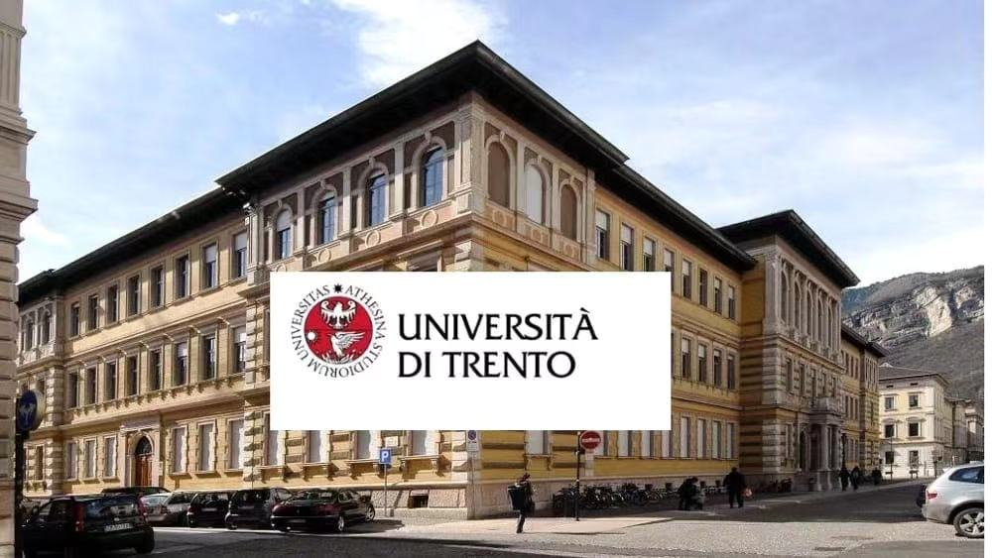
SCHEDULE
Sep. 28, arrive in Trento
Registration

Sep. 29 – 30, University of Trento

Symposium Programs
Topic 1: The Italian Background to the Rise of the Silk Industry
Topic 2: The Soft Diplomacy of Textiles
Topic 3: Motive, Technique and Meaning. East and West
Topic 4: Textile Traditions and Innovations
Topic 5: Rise of Silk Industry

Visits:
- The Castello del Buonconsiglio and the Museum of the Duomo
- Rovereto, MART Museum of Modern and Contemporary Art
- Ala di Trento The Textile Museum

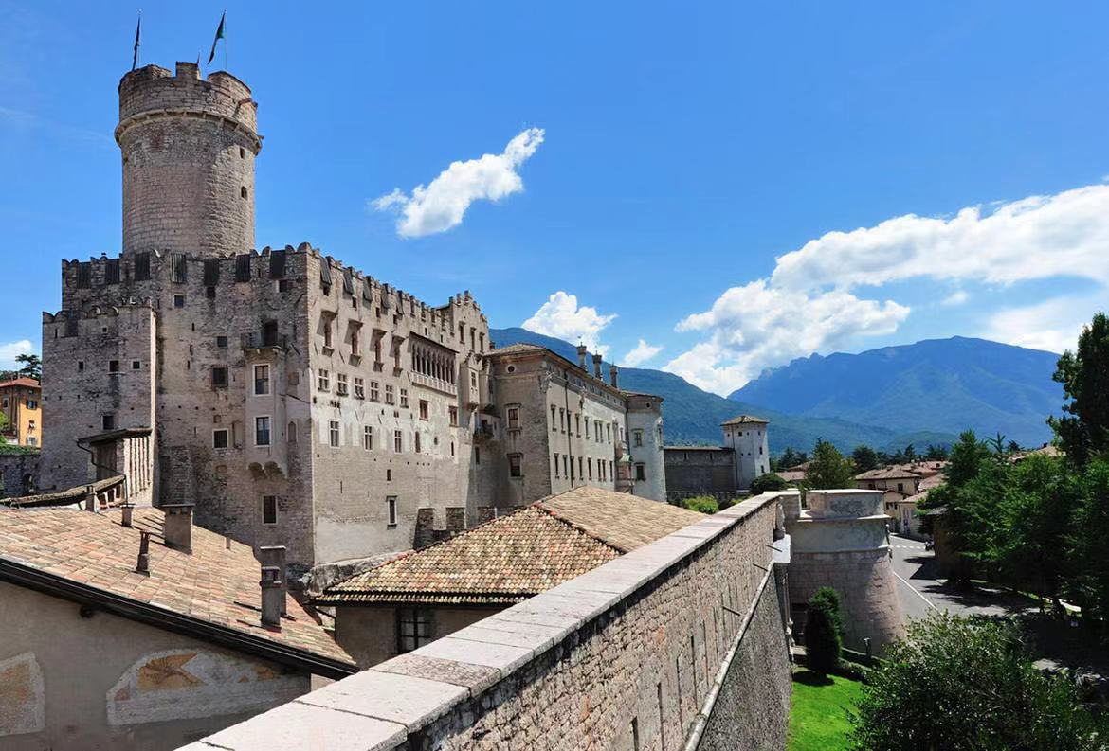
Trento, Castello del Buonconsiglio (Castle)

Oct. 1, Verona
Topic 6: Links to Orient (local scholars)
Visit:
- Museum of Castelvecchio (Cangrande della Scala Textiles) and other Monuments in Verona

Oct. 2, Florence
Topic 7: The Medici Patronage (local scholars)
Visits:
- Bargello National Museum (Carrand and Franchetti Textile Collection, Islamic Collection); Palazzo Davanzati; Casa Martelli
- Palazzo Pitti (Museo degli Argenti, Museo del Costume e della Moda)
- Possibly private visit of the Gallerie degli Uffizi by night

Oct. 3, Perugia
Topic 8: Textiles as Cathedrals’ Treasures (local scholars)
Visits:
- New Museum of Pope Benedict XI (medieval liturgical vestments made with “panni tartarici)
- On the way back stop in Prato and visit of the National Textile Museum

Oct. 4, Milan
Topic 9: Cross-cultural Influences of Motive, East and West
Visit:
- Castello Sforzesco; MUDEC Museo delle Culture; exclusive visit of the most important Textile Private Collection

Oct. 5, Departure or visit Como (optional)

Trento, Old Town

IASSRT SYMPOSIUM 5
CO-ORGANIZERS
- International Association for the Study of Silk Road Textiles (IASSRT)
- Centro Studi Martino Martini
- University of Trento
- China National Silk Museum
CO-CHAIRS: Riccardo Scartezzini, Feng Zhao
SPONSOR: Jinluntang Co. Ltd., Zhejiang University Press

CALL FOR PAPER SUBMISSIONS
Textile/ art/ social historians and textile scholars/ conservators are invited to submit a paper abstract between 250–1000 words to: 1257104802@qq.com. Registration form is also required (see below)
Submission deadline: May l, 2020
CONTACTS
- Elisa Gagliardi Mangilli: elisa.gagliardimangilli@gmail.com (Italy)
- Tina Zhou: 1257104802@qq.com (China)
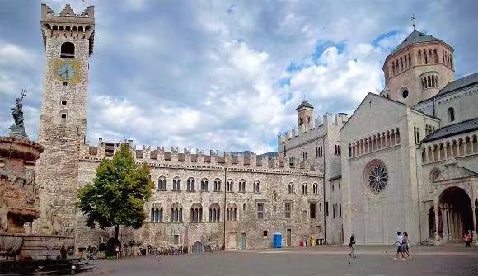
Duomo (Cathedral) and the Museum with an important textile collection
REGISTRATION FORM
First Name |  | Last Name
Title |  | Gender
Position and Institutions
Nationality
Email
Lecture title (if presenting)
Personal photo | Please send a head shot
Accompanying person
Send this form to: 1257104802@qq.com

